Problem 1) Given some specified frequencies, initial conditions, and force the program creates a plot of wave created by these values. The program then calculates, using Euler’s Method, the displacement and the velocity of the wave. Finally the program also plots the analytical solution. All of these plots allow for a greater analysis of the specified wave function.

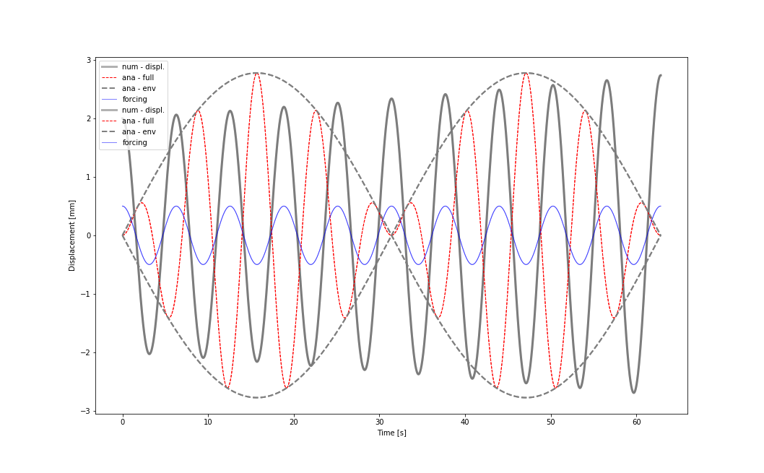

Problem 2) Using a similar process as the previous problem there is a change in the analytical solution that creates a rather large difference in their graphs.